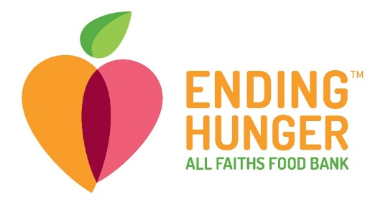

8171 Blaikie Ct.
Sarasota FL, 34240
For more information visit:
www.allfaithsfoodbank.org

FOR IMMEDIATE RELEASE

MEDIA CONTACT
Elodie McCartney Ward
Communications Manager
941-281-5866
emccartney@allfaithsfoodbank.org

All Faiths Food Bank recognized as one of top food banks in the country

Largest hunger relief organization in Sarasota and DeSoto counties distinguished as one of top four food banks out of 200 in Feeding America network

Sarasota, FL (November 19,2020) – All Faiths Food Bank was recognized by Feeding America as one of the top four – out of 200 - food banks of the year. Feeding America made the announcement during its Fall Leadership Virtual Summit honoring food bank leaders for their local community-building and contributions in the 2019 program year.
All Faiths Food Bank is a high-performing, trusted entity which has become known for its innovation and ability to mobilize the community and distribute millions of meals to those who are hungry. It was also recognized as a food bank whose methodology is on the cutting edge, using data to drive its work to ensure resources are allocated with maximum efficiency and innovation.
“We are not surprised that All Faiths Food Bank was identified as one of the top four food banks in the country,” said Keith Monda, All Faiths Food Bank board members and former Feeding America board chair. “From the feeding children through the Campaign Against Summer Hunger, emphasizing fresh produce and nutritious food, addressing rural hunger in DeSoto County, to partnering with health care, All Faiths is an incredible organization and an example of how a food bank can make a difference in its community.”
Efforts that distinguished All Faiths included: the Campaign Against Summer Hunger, which has inspired the community to raise over $10 million to feed nearly 100,000 children since its inception in 2014; the DeSoto Food and Resource Center, providing on-site client assessment, benefits assistance and referrals, serving predominantly Hispanic residents and agricultural workers, 70% of whom had never used All Faiths' services before; changing the mission and creating infrastructures and processes that incorporate community health principles; and its participation in the groundbreaking study that resulted in the Meal Deficit Metric, which is changing the way food banks address hunger in their communities.
All Faiths was also recognized for its culture, which emphasizes diversity, excellence, collaboration and teamwork. Feeding America noted that the organization invests in success through leadership opportunities, education and coaching. It is also seen as an essential partner, supporting Feeding America and Feeding Florida; All Faiths CEO Sandra Frank is currently the Board Chair of Feeding Florida.
“All Faiths Food Bank has become synonymous with the image of a healthy, nurturing and trustworthy provider,” said Nelle Miller, board chair of All Faiths. “Known for efficiency and, most importantly, the equitable distribution of millions of meals, the community has engaged to support, volunteer and cheer on an outstanding grassroots effort.”
For more about All Faiths, go to allfaithsfoodbank.org.

PHOTO ID: Members of All Faiths Food Bank’s leadership team include (from l-r) Denise Cotler, chief development officer; Colleen Reinert, strategic program officer; Mike Ziebell, chief accounting officer; Sandra Frank, CEO; and John Livingston, COO

About All Faiths Food Bank
All Faiths Food Bank is the only food bank and largest hunger relief organization in Sarasota and DeSoto counties. Rated 4-stars by Charity Navigator and a member of Feeding America, we provide millions of meals each year through robust programs and partnerships with charitable organizations in the community. In addition to food distribution, All Faiths Food Bank operates a roster of innovative direct service programs that not only solve the immediate problem of hunger but strive to end hunger by helping families and individuals gain long-term food security, better health outcomes and self-sufficiency. For more information visit allfaithsfoodbank.org.

About Feeding America
The Feeding America network of 200 food banks and 60,000 food pantries and meal programs provides assistance to more than 40 million people each year. Network food banks collectively distributed the equivalent of 5.17 billion meals in 2019.

###

